Poseidon

User Manual

CIDCO

D.D. 2024-12-02

## Index

**Index** **3**

**System Requirements** **4**

**Connection Instructions (WiFi)** **5**

**Web Interface - (ROS core not launched) [Yellow card]** **6**

**Web Interface - (System not ready)[Red card]** **7**

**Web Interface - (System ready)[Green card]** **8**

**Web Interface - (Record)** **9**

**Web Interface - (System Status)** **10**

**Web Interface - (Download dataset)** **11**

**Web Interface - (Automatic IMU calibration)** **12**

**Web Interface - (Manual IMu and Sonar calibration)** **13**

**Connection block diagram** **14**

**Wiring Diagram** **15**

## System Requirements

Power : 12Vdc from a 12V battery or a 12V psu.

*Never apply power on the system if the GNSS antenna and/or the Sonar is not connected!*

## Connection Instructions (WiFi)

First step : Connect to the **Hydro B** wifi network. The password to connect is : cidco1234

Second step : Open a web browser and type 192.168.1.1

## Web Interface - (ROS core not launched) [Yellow card]

If ROS is not launched, the web page will look like this.

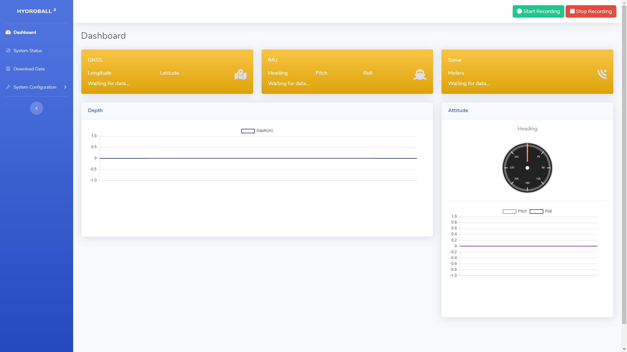

## Web Interface - (System not ready)[Red card]

If the system is not ready one of the three cards (NDSS, IMU, Sonar) will be red.

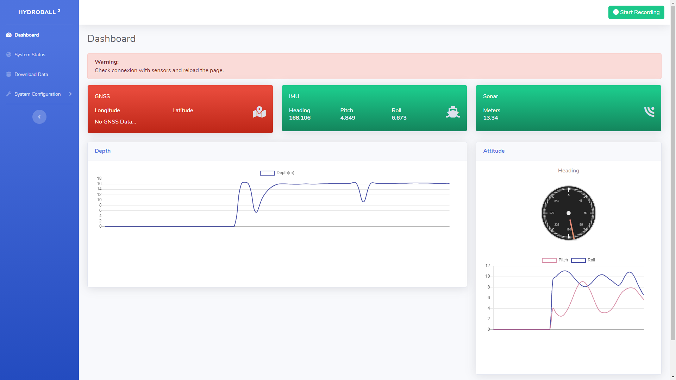

GNSS (red) - You have to wait a few minutes until the GNSS obtain the 3D fix. ...

IMU (red) - ...

Sonar (red) - ...

## Web Interface - (System ready)[Green card]

When the system is ready the three cards will be green.

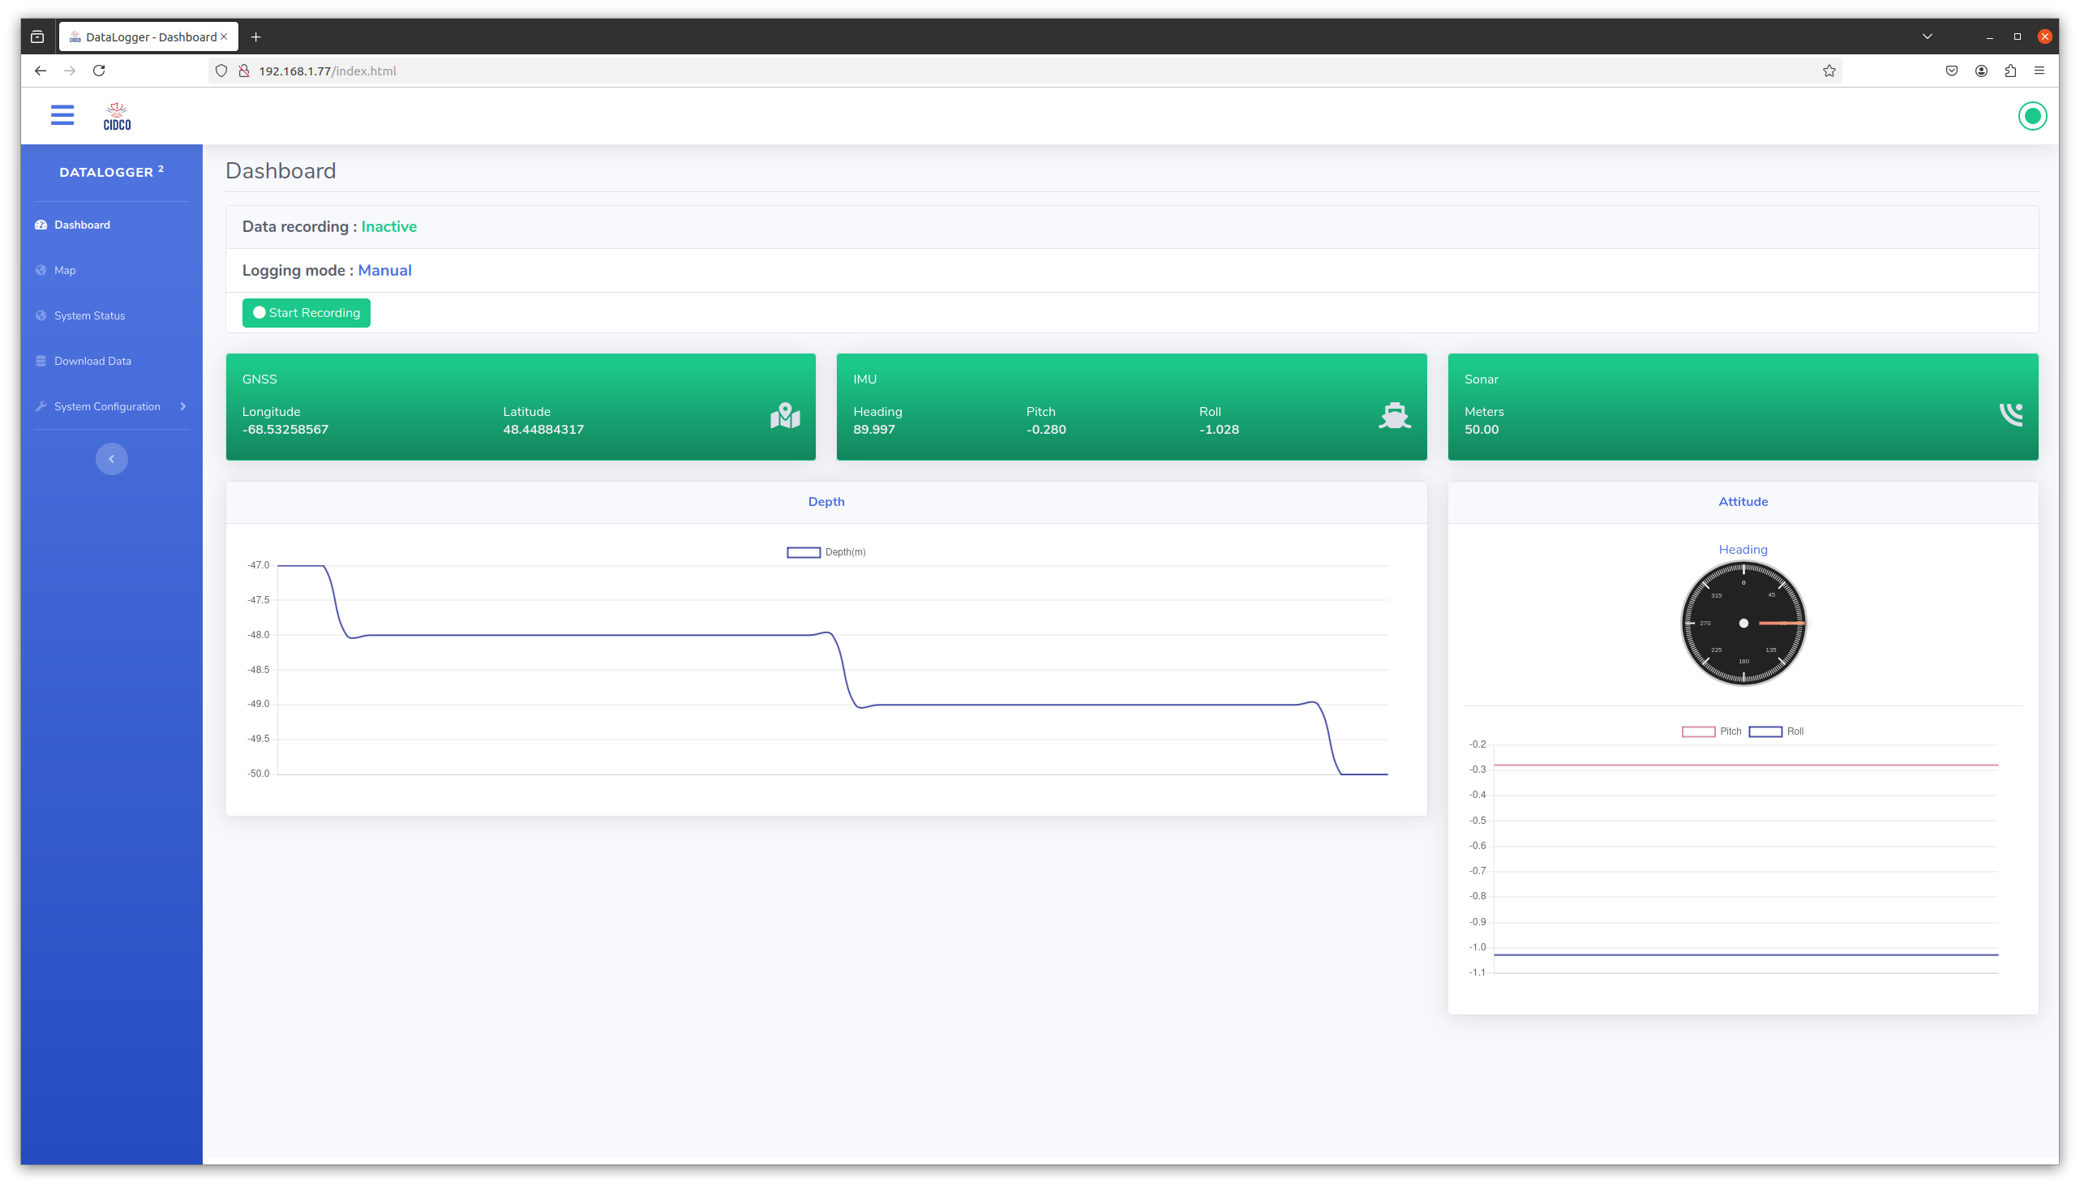

At this time you can start recording by pressing the green [Start Recording] button.

GNSS value : Decimal degrees

IMU value : Decimal degrees

Positioning convention : ENU

## Web Interface - (Record)

Data recording is in progress.

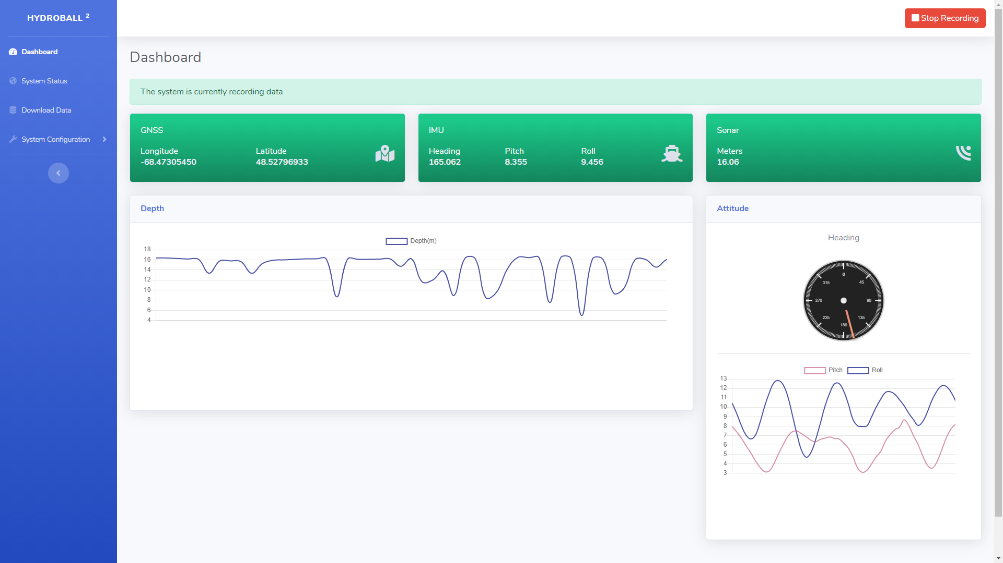

The system informs you that the recording is started in two ways.

The green button [Start Recording] toggle to red [Stop Recording]

A banner show [The system is currently recording data]

Note: The recording of RAW gps data begins when the system is powered on and stops only when the system is switched off.

## Web Interface - (System Status)

You can see the system status on the System Status page.

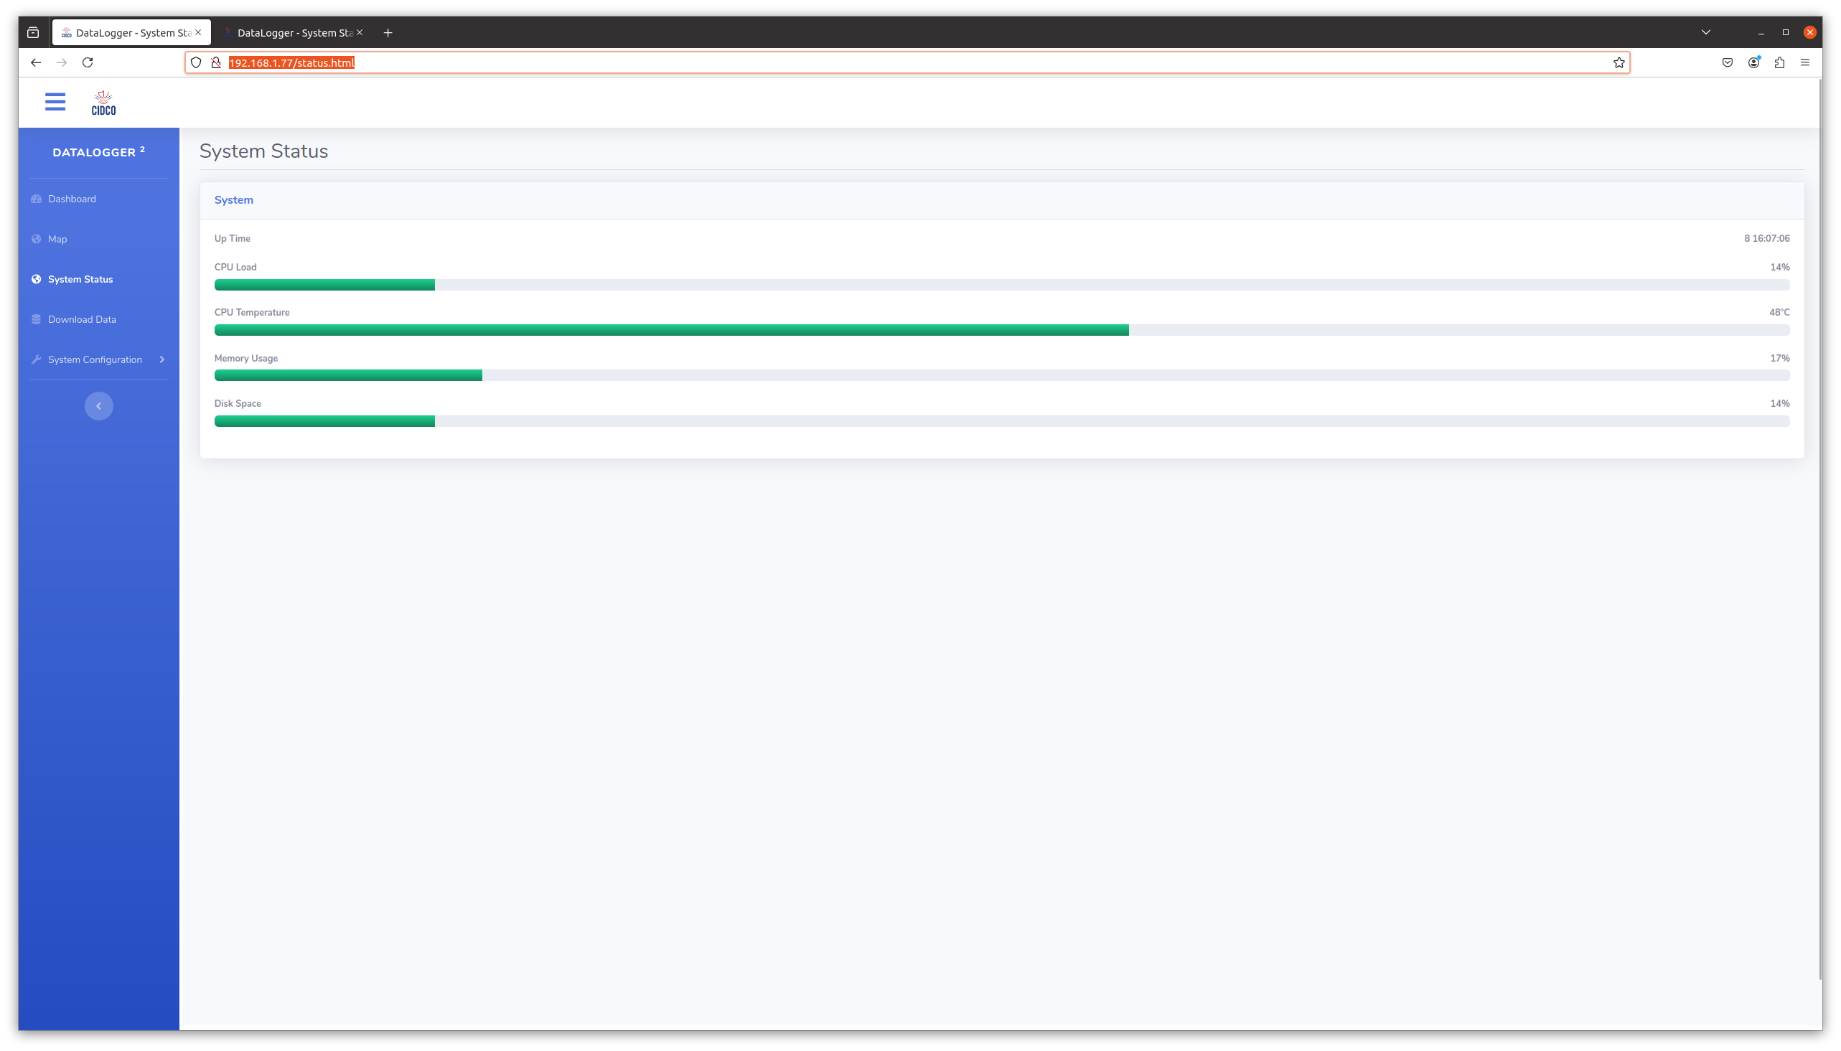

(System Status on Gen. A)

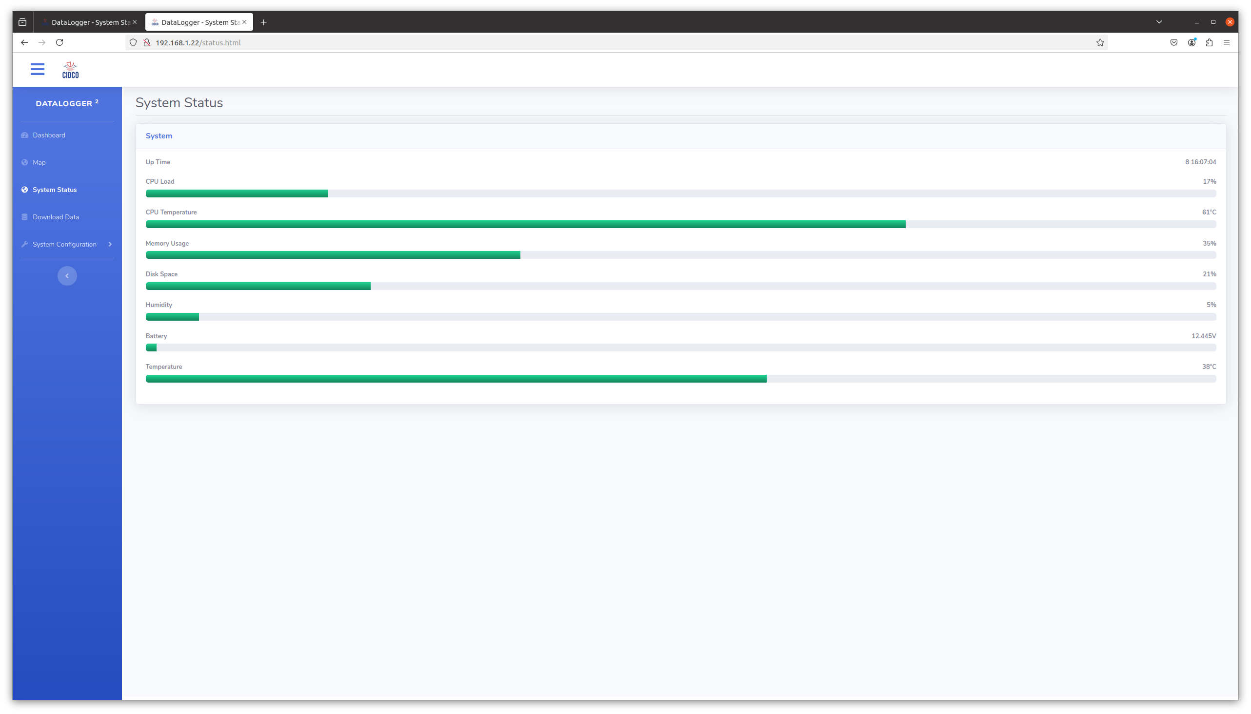

(System Status on Gen. B)

In this page you can monitor the state of the system.

CPU Load

CPU Temperature

Memory Utilization

Disk Space

## Web Interface - (Download dataset)

You can download the dataset and RAW gps data from the Download Data page

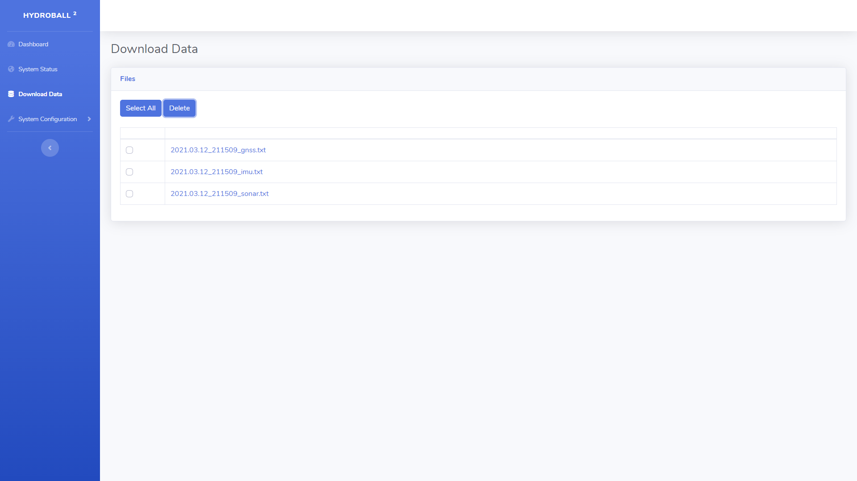

You can download each file by clicking on their name.

You can select the deleted files with the checkboxes or use the [Select All] button. When you press the [Delete] button a modal window will prompt you to confirm the deletion of the selected files.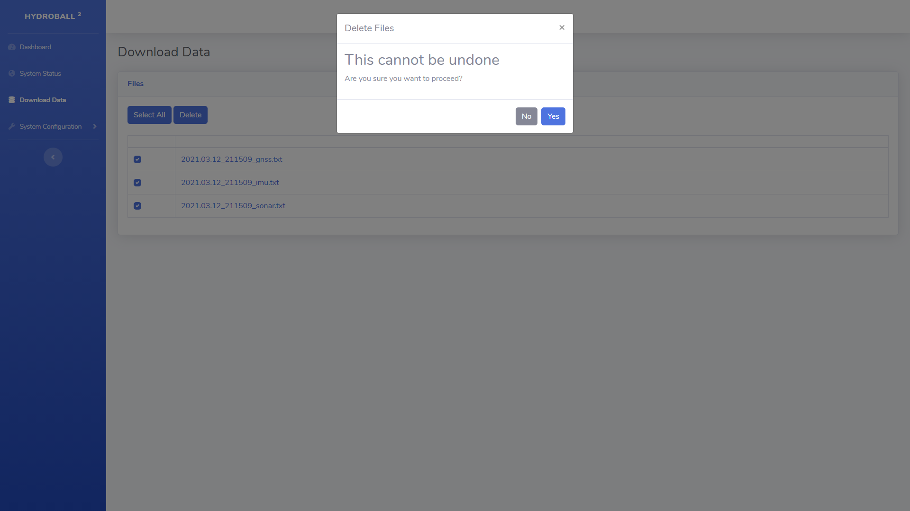

## Web Interface - (Automatic IMU calibration)

This page is used to launch the automatic calibration procedure of the IMU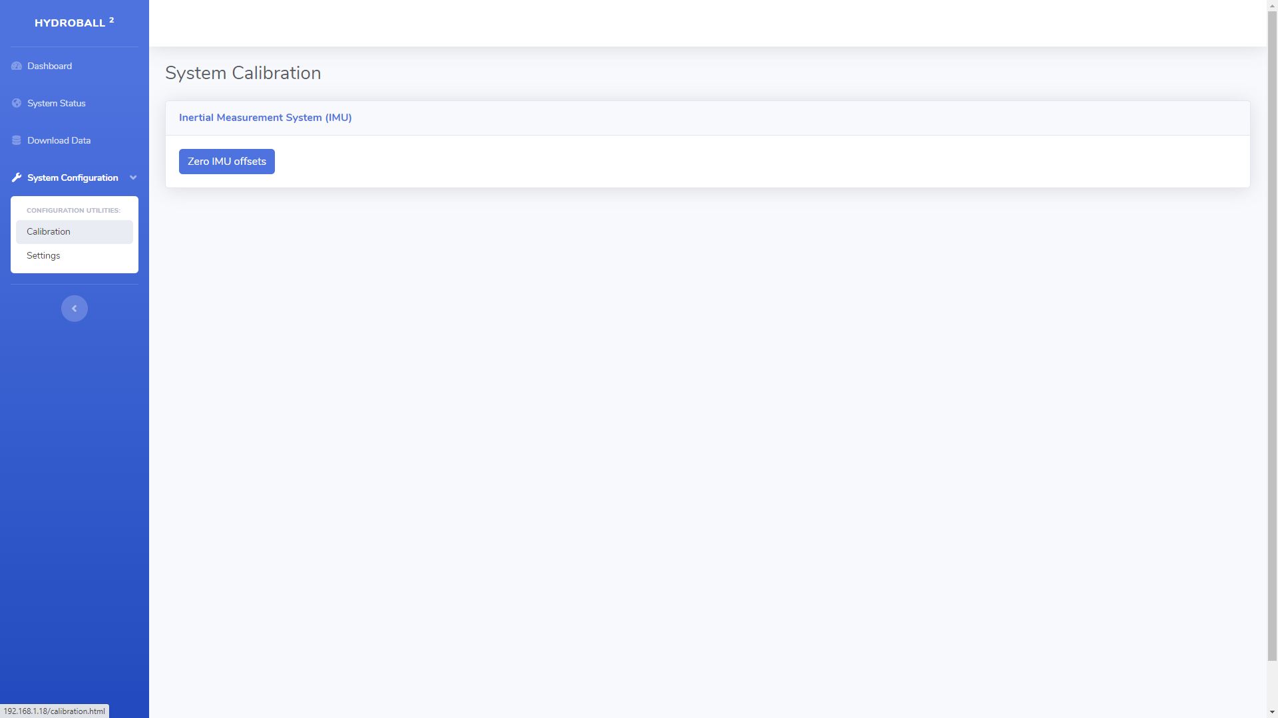

## Web Interface - (Manual IMu and Sonar calibration)

This page allows you to manually calibrate the IMU and Sonar.

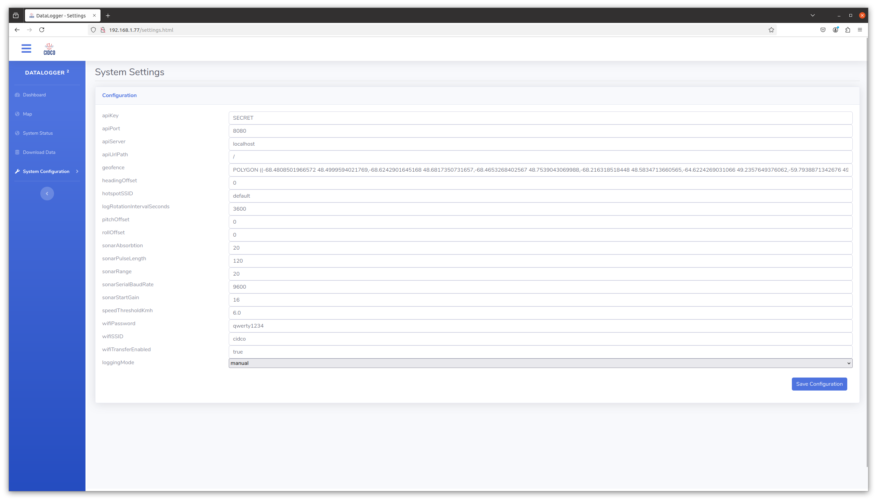

IMU Setting

Heading Offset value : Decimal degrees

Pitch Offset value : Decimal degrees

Roll Offset value : Decimal degrees

Imagenex Setting  
Sonar Absorption value : /10dB/M @ 675kHz

Sonar Pulse Length value : microseconds

Sonar Range value : Meters

Sonar Start Gain value : dB

Sonar range should be 5,10,20,30,40 or 50 Meters

CSB Integration

Api Key : 64 char from CSB server

Api Port : 433 or 80

Api Server : csb.cidco.ca

Api Url Path : /CSBWeb/JobServlet

Geo Fence : could be WKT polygon or multipolygon

default : MULTIPOLYGON (((-180 -90, -180 90, 180 90, 180 -90, -180 -90)))

The geofence function will stop the loggin of the sonar when you are outside of the polygon. The other data will be logged (GNSS, IMU, Vitals ...)

Hotspot SSID : SSID of the hydroblock/hydroball : default = HydroB

Log Rotation Interval :Delay for the log rotation in seconds : default = 3600 (1h)

Sonar Serial Baud Rate : Serial baudrate for the sonar interface : Default 9600

usual value 4800, 9600, 33600,115200

Speed Threshold : Speed Threshold to start and stop the loging : default 6 kmh  
ex : start the record when the speed is over 6kmh and stop under 6kmh

(The function will be deprecated)

If the device is equiped of an wifi module for automatic files transfert.

Wifi SSID : SSID of your wifi network

Wifi Password : Password of your wifi

Wifi Transfer Enable : true to enable the files transfert when the wifi is detected.

Logging Mode :

manual : you have to manualy start and stop the logging from the dashboard

speed : the logging will start when the device will move faster than the value of Speed Threshold filed.

always : the logging will start automaticly at boot of the device.

## Connection block diagram

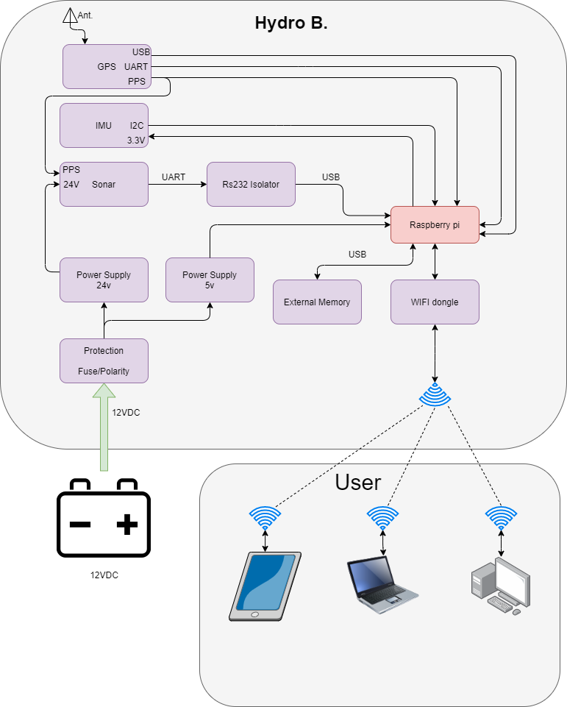

## Wiring Diagram

